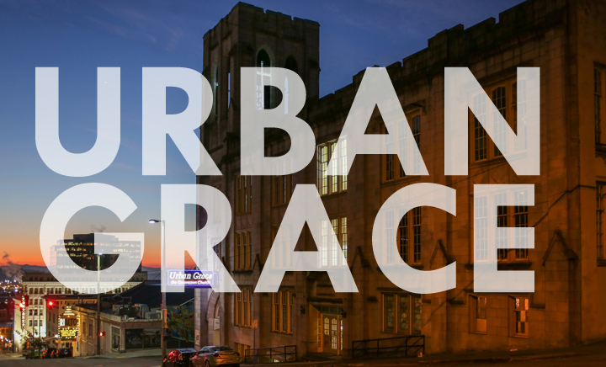

URBAN GRACE CHURCH
Urban Grace is an ecumenical church located in the heart of downtown Tacoma, WA. We seek to create a space that is truly welcoming to everyone; this is reflected in our congregation that is composed of young families, professionals, those struggling with homelessness and mental illness, those who are uncertain what they believe, and lifelong Christians who want new ways to live out their faith. We have a very ecumenical vibe with members from various Christian traditions and a worship service that varies from gospel to high liturgy. We are honored to be joined by former members of First Baptist church, which closed in 2005 and bequeathed her mission to downtown and her building to our bourgeoning community.
Urban Grace serves our city through an emphasis on Social Justice, Service, and the Arts. Our mission and commitment are reflected in the use of our 40,000 sq. ft. historical building which functions as a community center for Social Service organizations, Christian ministries, and Arts organizations. We have an 850-seat theatre, a dance studio, the city’s largest free community meal, and around twenty organizations that use our building every week.
Urban Grace has experienced consistent growth over the last five years; in the four years leading up to the pandemic our average attendance has grown from about 75 to 165 and the average number of kids on Sunday has grown from fewer than 10 to more than 40. We have seen an influx of folks with an evangelical background who are looking for a more inclusive, justice-oriented spiritual community. We have not met for worship in our building since the pandemic began, but our congregation has remained stable and we have completed significant investments in our facility.
As we prepare to return to worshiping together we are seeking a candidate who will collaborate with the Director of Congregational Care to support programs and plan events that foster spiritual formation through service partnerships, social justice education and awareness, contemplative practices, and the worship of God.

Urban Grace

Job Description and Qualifications

Position: |  | Congregational Care Assistant
Department: |  | Congregational Care
Reports To: |  | Director of Congregational Care
Type of Position: |  | Part-time, 9 hours/week, $18/hour
Issue or Revised Date |  | 05-01-2021
Basic Summary
Provide assistance in all duties of Director of Congregational Care including event and program development in order to foster connection in the congregation, spiritual formation through service partnerships, social justice education and awareness, contemplative practices, and the worship of God.

Essential Job Functions
 | Connection in the Congregation: Creation, coordination, and hosting of events and initiatives that foster connection among congregants i.e. coffee hour, retreats, holiday parties, We Deliver Love, etc. Additionally, phone calls, texts, emails and personal visits to congregants in need of care and celebration.
 | Spiritual Formation through Service: Coordinate with social service partners to create opportunities for congregants to serve. Market, recruit, and facilitate these programs. Includes, but not limited to, Urban Grace Community Breakfast, World Relief, MAREPA, L’Arche, and the Center for Urban Peacemaking.
 | Social Justice Initiatives: Identify, engage, and support congregants in their passion for a variety of social justice concerns including, but not limited to, homelessness, racial reconciliation, and LGBTQIA+ advocacy. Plan and host events that educate or increase awareness related to social justice concerns.
 | Contemplative Practices: Create or recruit practitioners to create, market, and host live and online events that foster spiritual formation through contemplative practices i.e. prayer vigils, mindfulness sessions, advent and lenten services, etc.
 | Worship Services: Assist in worship planning and in worship services as needed.
 | Other duties as assigned. This may include assisting the worship team, children’s ministry team, and the pastor.

Required Qualifications
- Education: Bachelor’s degree preferred
- Experience: Minimum two year experience in a church setting (professional or volunteer) preferred
- Proficiency in Microsoft Office software
- Strong verbal and written communication skills in English

Physical Demands
- While performing the duties of this job, the employee is regularly required to talk, hear, read, write, and type at a computer.
- Specific vision abilities required by this job include close vision and the ability to adjust focus.
- Ability to climb stairs and navigate a large, historic 4-story building that does not have an elevator.
- Ability to grasp, lift, carry, and move objects of up to 25 lbs.

Work Environment
- The majority of the time is spent in general office working conditions, from home or in the community.
- Some exposure to noise, odors, and worksite hazards.

Comments
- Be able to provide spiritual leadership in Urban Grace’s welcoming and ecumenical environment
- Be able to create a safe, creative, and respectful learning environment that honors the dignity of each person and their experiences of life and faith
- Be flexible to handle the changing needs of the church
- Be reliable, collaborative, self-motivated, organized, and have high integrity
- Have a flexible schedule with Sunday mornings required

All employees are required to satisfactorily perform the essential duties and responsibilities of their position. • The essential duties and responsibilities listed above are not intended to be construed as an exhaustive list of all responsibilities, duties and skills required. • Reasonable accommodations may be made to enable individuals with disabilities to perform the essential functions of this job.

