Urban Grace

Job Description and Qualifications

Position: |  | Facility Manager
Department: |  | Facilities
Reports To: |  | Director of Operations
Type of Position: |  | Part-time (starting at 15 hours/week), non-exempt
Issue or Revised Date: |  | 2/8/2021
Compensation: |  | $19/hour
Basic Summary
Provide oversight of facilities administration to support the ministry of Urban Grace and its ministry partners.

Essential Job Functions
 | Leasing & Rentals: Create contracts and coordinate with clients to lease office and/or event space at Urban Grace. Coordinate provision of any services or features promised to clients in their lease/rental agreement including planning for or providing any room set ups or other services for ongoing and special events.
 | Facility Management: Supervise the custodial and maintenance staff, create custodial schedules, and order supplies. Maintain a master facility schedule to coordinate facility usage by Urban Grace and clients/tenants.
 | Maintenance Oversight: Coordinate and oversee master maintenance schedule according to building and tenant needs. Supervise maintenance staff, contractors, and volunteers as necessary to make repairs and improvements in accordance with the spending authority established by Urban Grace.
 | Communication: Consistent, clear, and immediate communication to Director of Operations and/or Pastor about observations to note, requests, and concerns. Meet with the Trustees, Council and church staff and congregation as requested for the purposes of coordination, communication, and research. Provide reports as requested.
 | Risk Management: Actively seek to minimize the exposure of Urban Grace to risks by promoting safety, compliance with codes and laws, and insurance carrier recommendations and requirements.
 | Other duties as assigned.

Qualifications
- Professional, honest, self-motivated and hard-working
- Caring attitude, excellent people skills, and high integrity
- Be able to work under deadlines and be flexible to handle the changing needs of the church
- Respect for all people and the Christian church

Requirements
- 2 years experience preferred
- High school diploma or GED equivalency
- Proficiency in Microsoft Office and ability to learn new programs quickly
- Verbal and written communication skills in English
- Certification/Licensure: current driver’s license, automobile insurance, and vehicle

Physical Demands
- While performing the duties of this job, the employee is regularly required to talk, hear, read, write and type at a computer.
- Job requires physical strength and ability to perform minimal to moderate manual labor, including walking, climbing stairs, and the ability to lift at least 35 pounds.

Work Environment
- General office working conditions for a downtown location.
- The noise level in the work environment is usually minimal.
- Some exposure to noise, odors, and worksite hazards.

Urban Grace is an Equal Employment Opportunity employer.

Our Vision of and for the Urban Grace facility…

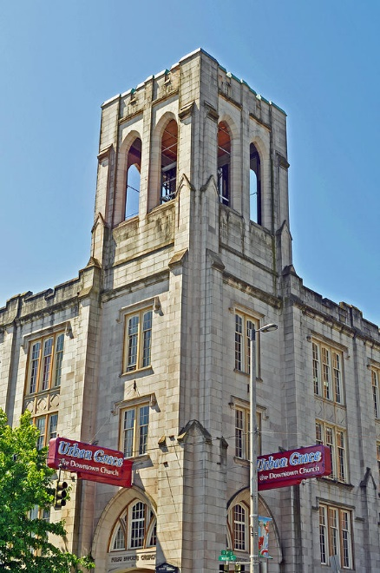
We see our historic 40,000 square foot facility as a tremendous asset not only to our congregation but also to our community. Our forbearers built a building larger than they could fill in anticipation of the future. Today, our facility has become a cornerstone in the downtown neighborhood and a sought after venue. Besides the programs of the Urban Grace congregation, we open our doors to thousands of people each year as they attend concerts, meetings, dance classes, therapy sessions, and more. We currently house over fifteen nonprofits and arts organizations as well as individual artists and therapists for office space or regular usage.
In alignment with our values, we partner with groups or individuals working in education/advocacy, the arts, social services, and/or worship. We recognize that our historic building is not simply a place where events happen or people work, but it is an integral part of who we are and the legacy we are privileged to continue. Urban Grace is committed to not only preserving our church building but improving its facilities so that the broader community may benefit into the future. In 2017, Urban Grace began its Building Together Capital Campaign seeking funding for exactly those reasons. After successfully raising more than $1.2 million, Urban Grace was able to complete dozens of projects to improve and sustain the facility for decades to come.
Those before us chose to build, maintain, and uphold a building that was both physically and figuratively bigger than its people in order to serve their community for the long-term. We seek to graciously do the same.

Facility Stats
Location: Tacoma, Washington, downtown
Denomination: Inter-denominational, ecumenical
Facility: Built in 1925, 40,000 square feet, 4 story, sanctuary seats 850, chapel seats 80
Partners: More than 15 nonprofits, arts-related organizations and individuals, and therapists housed for office space or regular usage
Activity: On average, more than 850 people/week enter our building for a multitude of activities, events, and classes. At any one time, there may be a dance class, music lesson, nonprofit training, NA meeting, and small concert happening simultaneously at Urban Grace.
General Condition and Maintenance: The projects we completed during our 2017-2021 Building Together Capital Campaign, were based off of maintenance priorities laid out in our Feasibility Study and Historic Structures Report. Though we were unable to complete all projects recommended to us, we prioritized those that were the most crucial including masonry, roofing/siding, glasswork, plumbing, etc. We are grateful that for a nearly 100 year old building, the structural integrity of the building continues to hold up and will continue to work towards completing the projects laid out in our professional assessments.

