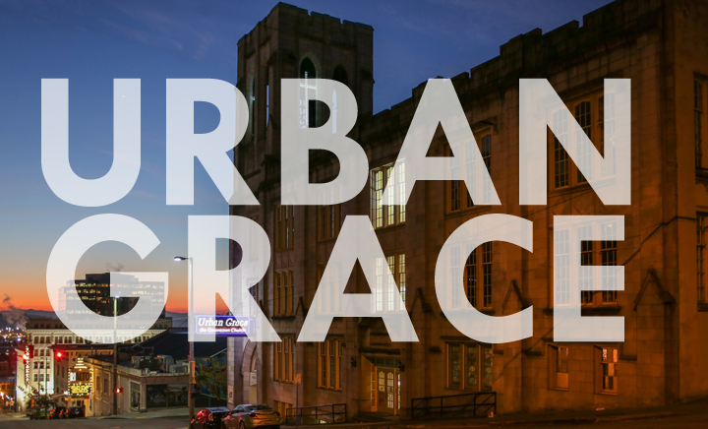

URBAN GRACE CHURCH
Urban Grace is an ecumenical church located in the heart of downtown Tacoma, WA. We seek to create a space that is truly welcoming to everyone; this is reflected in our congregation that is composed of young families, professionals, those struggling with homelessness and mental illness, those who are uncertain what they believe, and lifelong Christians who want new ways to live out their faith. We have a very ecumenical vibe with members from various Christian traditions and a worship service that varies from gospel to high liturgy. We are honored to be joined by former members of First Baptist church, which closed in 2005 and bequeathed her mission to downtown and her building to our bourgeoning community.
Urban Grace serves our city through an emphasis on Social Justice, Service, and the Arts. Our mission and commitment is reflected in the use of our 40,000 sq. ft. historical building which functions as a community center for Social Service organizations, Christian ministries, and Arts organizations. We have a 900-seat theatre, a dance studio, the city’s largest free community meal, and around twenty organizations that use our building every week.
Urban Grace is undergoing a period of rapid growth. In the last two years the size of our congregation has effectively doubled; our average attendance has grown from about 75 to 150 and the average number of kids on Sunday has grown from fewer than 10 to around 30. We have seen an influx of folks with an evangelical background who are looking for a more inclusive and open community. In the fall of 2017 we kicked off our Building Together Capital Campaign to invest and upgrade our historic building. The campaign exceeded expectations and we are in the midst of planning for construction. The growth of the church and the demands of the capital campaign have shifted the role of the staff, and in response our leadership council has created two new positions to help us meet the needs of the congregation. We have already hired a program administrator to help coordinate worship, volunteers, and committee-based ministries and we are currently seeking a Minister of Spiritual Care to assist the pastor and focus on faith formation. We have capable teachers, small group leaders, and folks looking to get involved, so we seek someone to restructure and guide these ministries. The Minister of Spiritual Care will have staff support and flexibility to tailor the role to the gifts and passions they bring.

Job Description and Qualifications

Position: |  | Minister of Spiritual Care
Department: |  | Faith Formation
Reports To: |  | Pastor
Type of Position: |  | Part-time, 15 hours/week, $18/hour
Issue or Revised Date |  | 6/4/18
Basic Summary
To support the needs of our growing congregation, we seek an individual who can provide leadership, teaching, planning, and staff/volunteer coordination of adult faith formation opportunities beyond Sunday morning.

Essential Job Functions

 | Adult Faith Formation Classes on Sunday mornings and/or weekday evenings: Work with staff to coordinate and/or lead seasonal or short-term programs such as lecture based classes, topical discussions, or guided spiritual practices. Coordination includes marketing, recruitment, scheduling, communication, etc. (35%)
 | Small Groups: Work with staff to create and coordinate adult small groups including training of leaders, regular check ins, providing resources, marketing, and communication. (35%)
 | Spiritual Direction and/or Care: Depending on the qualifications of the individual, this could be providing opportunities for congregants to attend spiritual care classes, receive one-on-one guidance, mentoring, pastoral care, etc. (20%)
 | Meetings and Communication: Meet with staff and pastor weekly to discuss direction and ideas for church programming and worship services. Consistent and clear communication to staff and volunteers about observations, requests, and concerns. Provide reports as requested. (10%)
 | Other duties as assigned.

Required Qualifications
- Education: Bachelor’s degree required. Theological Education preferred.
- Experience: Minimum two-year experience in a church setting (professional or volunteer) preferred.
- Proficiency in Microsoft Office software.
- Strong verbal and written communication skills in English.

Physical Demands
- While performing the duties of this job, the employee is regularly required to talk, hear, read, write, and type at a computer.
- Specific vision abilities required by this job include close vision and the ability to adjust focus.
- Ability to climb stairs and navigate a large, historic 4-story building that does not have an elevator.
- Ability to grasp, lift, carry, and move objects of up to 30 lbs.

Work Environment
- The majority of the time is spent in general office working conditions.
- Some exposure to noise, odors, and worksite hazards.

Comments
The Minister of Spiritual Care must:
- Be able to provide spiritual leadership in Urban Grace’s welcoming and ecumenical environment
- Be able to create a safe, creative, and respectful learning environment that honors the dignity of each person and their experiences of life and faith
- Be able to prioritize their time, working with staff and volunteers to help accomplish the tasks that fall outside the scope of their hours or expertise
- Be affirming of the LGBTQA community
- Be flexible to handle the changing needs of the church
- Be reliable, collaborative, self-motivated, organized, and have high integrity
- Have a flexible schedule with Sunday mornings required

All employees are required to satisfactorily perform the essential duties and responsibilities of their position. • The essential duties and responsibilities listed above are not intended to be construed as an exhaustive list of all responsibilities, duties and skills required. • Reasonable accommodations may be made to enable individuals with disabilities to perform the essential functions of this job.

