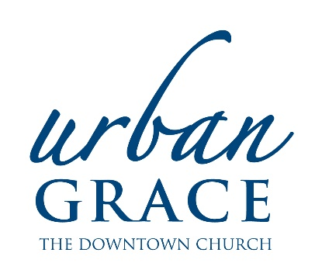
Urban Grace

Job Description and Qualifications

Position: |  | General Maintenance Worker
Department: |  | Facilities
Reports To: |  | Facilities Coordinator
Type of Position: |  | Part-time, 6 hours/week, non-exempt
Compensation: |  | $25/hour
Issue or Revised Date |  | 10/18/17
Basic Summary
Provide consistent and thorough upkeep of the building through general maintenance in order to support the ministry of Urban Grace and its ministry partners.
Essential Job Functions
1. | Various maintenance projects including general repairs, carpentry, painting, plumbing, electrical, etc. as assigned and assisting in creating project list, picking up project supplies, etc.
2. | Monitoring of building equipment and planning for preventative maintenance in partnership with Facilities Coordinator.
3. | Security during hours of operation including securing doors and windows, reporting any suspicious behavior, checking rooms/hallways, etc.
4. | Consistent, clear and immediate communication to Facilities Coordinator about observations to note, changes in project plan, requests and concerns.
5. | Other duties as assigned.

Qualifications
- Reliable, honest, self-motivated and hard-working
- Have a caring attitude, excellent people skills, and high integrity
- Able to work under deadlines and be flexible to handle the changing needs of the church
- Respect for all people and the Christian church

Requirements
- Working knowledge of plumbing, electrical, carpentry, painting, etc. and the basic tools required for each
- Flexible evening and weekend schedule and ability to be on call for maintenance emergencies
- At least two years experience required
- High school diploma or GED equivalency
- Proficient in English both verbal and written
- Certification/Licensure: current driver’s license, automobile insurance, and vehicle

Physical Demands
- While performing the duties of this job, the employee is regularly required to talk, hear, read, write and type at a computer.
- Job requires physical strength and ability to perform moderate to heavy manual labor, including frequent bending, walking, climbing stairs and the ability to lift at least 50 pounds.
- Stamina to maintain continuous physical effort for the duration of the shift on a regular basis.

Work Environment
- General labor working conditions for a downtown location.
- The noise level in the work environment is usually moderate.
- Some exposure to noise, odors, and worksite hazards.

Urban Grace is an Equal Employment Opportunity employer.

